Creelman Exam Questions: Human Biology ATAR Course Units 3 and 4, 2019

10.
The following list relates to characteristics of the nervous system.

(2014:1.04)

The next three questions refer to the diagram shown below.
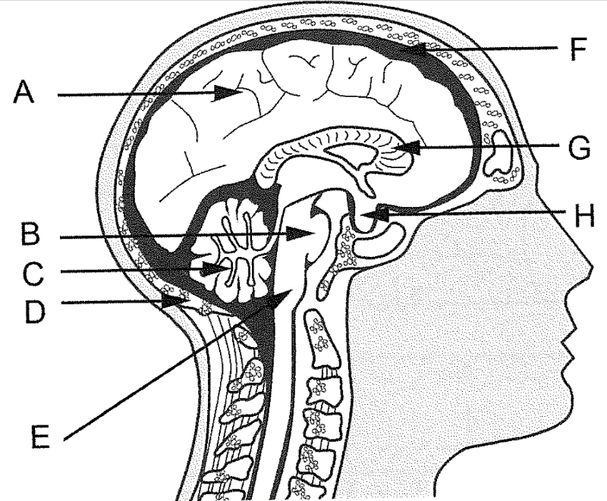
Chapter 2: Nervous system

- effectors are usually skeletal muscles
- involves parasympathetic and sympathetic nerves
- carries information from the CNS to effectors
- carries information from the brain to the spinal cord
- is voluntary, apart from reflexes
- usually controls involuntary actions

The characteristics that describe the somatic division of the peripheral nervous system correctly are

- i, ii, iii.
- iv, v, vi.
- i, iii, v.

13.

(2015:1.14)

- ii, iii, vi.

The part of the brain responsible for the maintenance of posture and balance is
- H.
- G.

- C.
- A.

14. (2015:1.15)
Two of the structures labelled on the diagram provide protection for the brain. They are
- D and F.
- D and B.
- H andF.
- Hand B.

12.
Which of the following is not a fight-or-flight response?
- increased sweat production
- constriction of the pupil of the eye
- relaxation of the walls of the urinary bladder
- decreased saliva secretion
(2014:1.18)

Next two questions refer to the brain diagram shown below.

A Corpus callosum
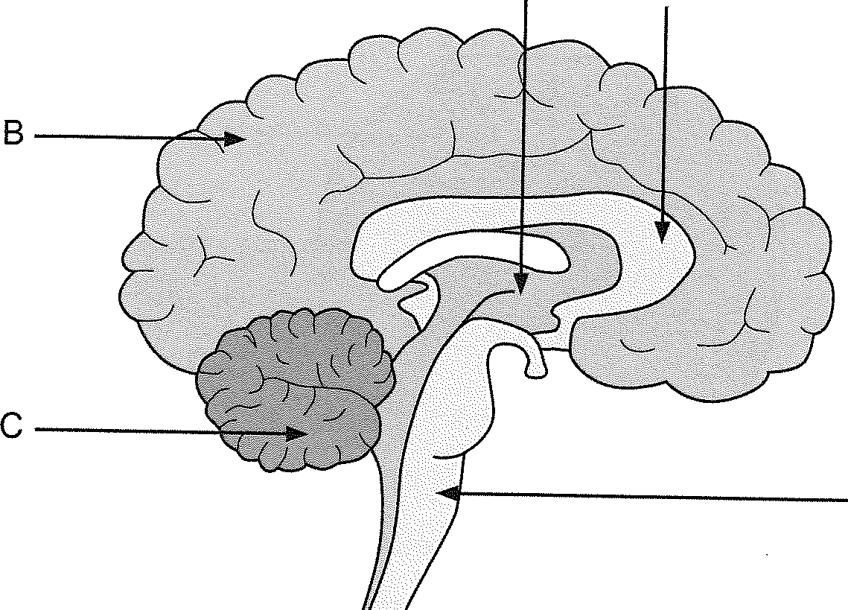
D

Which part of the brain is responsible for regulating heart rate?
  - A
  - B
  - C
  - D

27.

The corpus callosum relays information to and from the
- cerebral hemispheres.
- hemispheres of the cerebellum.
- hypothalamus.
- spinal cord.

33

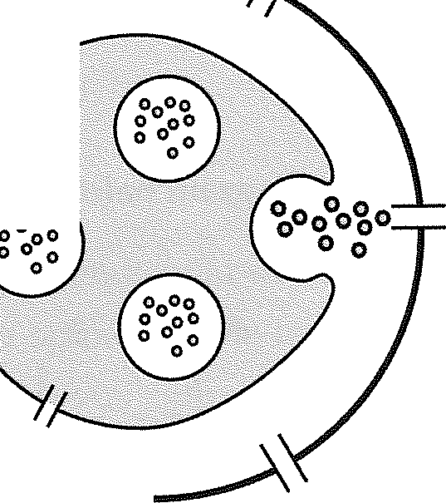

Creelman Exam Questions: Human Biology ATAR Course Units 3 and 4, 2019

The next question refers to the diagram shown below.

30.

Chapter 2: Nervous system

(2017:1.20)

Cross-section of the spinal cord
When a nerve impulse reaches the end of a neuron, it is not connected directly to the adjacent neuron. There is a gap between the neurons called a synapse.
The diagram below is a representation of a synapse.

/'

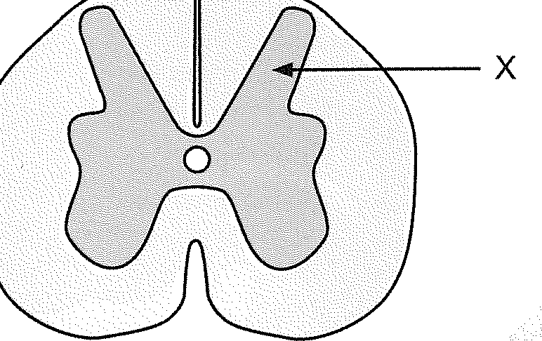
Presynaptic neuron Postsynaptic neuron

28.
Which of the following is correct about the part labelled X?
- grey matter, which is also found on the outer surface of the cerebrum
- white matter, which is also found on the outer surface of the cerebrum
- grey matter, which is also found inside the cerebrum
- white matter, which is also found inside the cerebrum

29.
Which of the following are features of a reflex action?
- spontaneous, involuntary and rapid
- involuntary, stereotyped and require a stimulus
- require a stimulus, voluntary and rapid
- stereotyped, spontaneous and voluntary

34

(2017:1.13)

(2017:1.19)

Which of the following is involved in enabling the nerve impulse to reach the adjacent neuron?
- Mitochondria in the postsynaptic membrane release neurotransmitters into the synapse.
- Vesicles in the presynaptic knob are stimulated by the entry of calcium ions to release neurotransmitters.
- Neurotransmitters diffuse across the synapse and bind to receptors on the presynaptic knob.
- Calcium ions are released by vesicles in the postsynaptic membrane and cross the synapse to release neurotransmitters.

31. (2017:1.23)
Opening a closed door quickly, you are surprised by someone standing on the other side. Your pupils dilate and your heart and breathing rates increase. Which branch of the nervous system has been activated?
- central
- somatic
- parasympathetic
- sympathetic

32. (2017:1.30)
Which of the following is correct in relation to the afferent and efferent nervous systems?
Afferent nervous system | Efferent nervous system
Carries nerve impulses from the receptors to the CNS | Carries nerve impulses from the CNS to the receptors
Carries nerve impulses to the voluntary muscles from the CNS | Carries nerve impulses to the CNS from the voluntary muscles
Carries nerve impulses from the CNS to the receptors | Carries nerve impulses from the receptors to the CNS
Carries nerve impulses from the receptors to the CNS | Carries nerve impulses from the CNS to the voluntary muscles

(a)

(b)

(c)

(d)

35

l_.!. lf,,P.,--

Creelman Exam Questions: Human Biology ATAR Course Units 3 and 4, 2019

The next two questions refer to the diagram below:


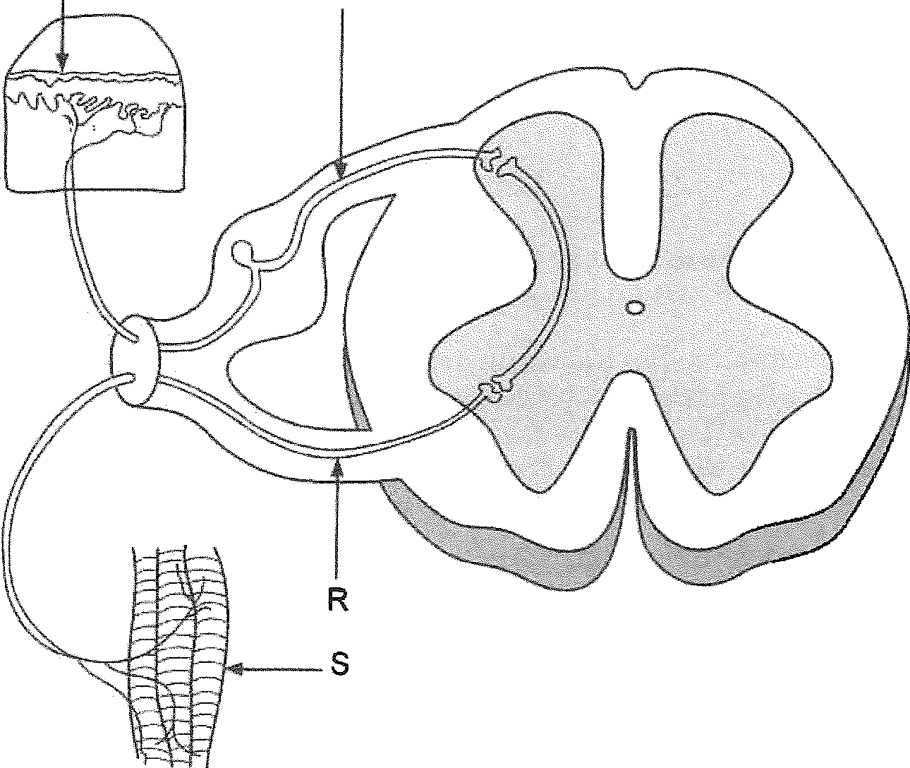
p Q

38.
The structure labelled 'R' can be described as an
  - afferent neuron carrying information away from the spinal cord.
  - afferent neuron carrying information toward the spinal cord.
  - efferent neuron carrying information away from the spinal cord.
  - efferent neuron carrying information toward the spinal cord.

(2018:1.14)

39. (2018:1.15)
Which of the following statements about the detection of a stimulus in the above reflex arc is correct?
- detected by receptors labelled 'P' and transmitted through sensory neurons labelled 'Q'
- detected by receptors labelled 'S' and transmitted through sensory neurons labelled 'R'
- detected by receptors labelled 'S' and transmitted by interneurons labelled 'R'
- detected by sensory neurons labelled 'P' and transmitted through motor neurons labelled

'Q'

38

Creelman Exam Questions: Human Biology ATAR Course Units 3 and 4, 2019

SHORT ANSWER QUESTIONS

43. [13 marks]

(2013:2.39)

(iii) State a reason why reflex arcs are important.

Chapter 2: Nervous system

[1]

Parts (a), (b) and (c) of the question refer to the diagram below, which shows a cross section of the spinal cord and components of a reflex arc.

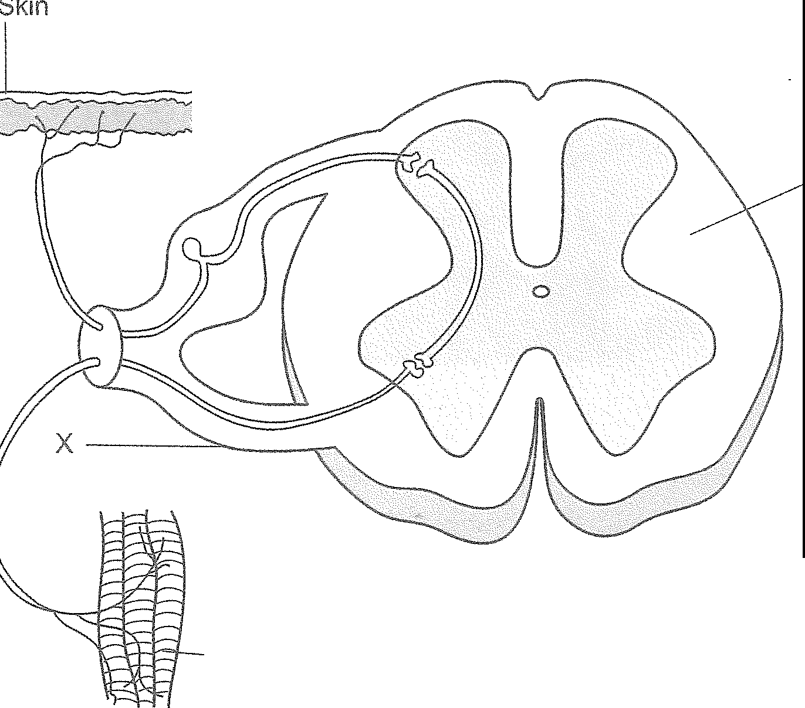
(c)
Muscle fibres

y
CIPA is a rare congenital disorder caused by a mutation that prevents the formation of nerve cells which are responsible for transmitting signals of pain.
Would these nerve cells be located closer to the skin or to the muscle fibres, as shown on the diagram? Explain your answer. [2]

- (i) Name the type of nerve fibres found in the root labelled 'X'.
[1]

- The skin and muscle fibres shown in the diagram are associated with a reflex arc.

  - Draw an arrow on the diagram to show the direction of a nerve impulse through this reflex arc. [1]

  - State three important functional properties of reflexes. [3]

40

41

44
  - Describe the pathway involved in a spinal reflex which brings about a fast, automatic response following stimulation of a pain receptor. [4]

CONTINUED NEXT PAGE
45

Creelman Exam Questions: Human Biology ATAR Course Units 3 and 4, 2019

- Explain how a nervous impulse can travel from one neuron to the next. [3]

- (11 marks]
Chapter 2: Nervous system

(2016:2.32)

The following question refers to the diagram of the skin shown below.

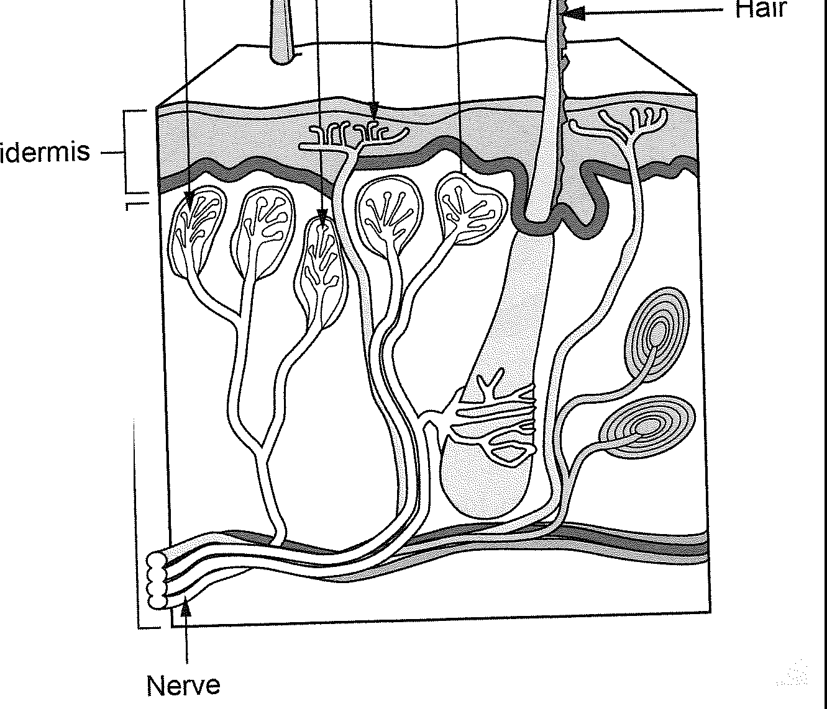
w X y z
Dermis

The autonomic and somatic divisions of the peripheral nervous system are both involved in the transmission of nervous impulses from the central nervous system to effectors. However, they differ in both structure and function. Provide two differences between the autonomic and somatic divisions. [4]

Nerve

Identify the type of receptor labelled Y.

[1]

Receptors W, X and Z are all located in the upper region of the dermis, but receptor Y is located in the epidermis. Explain why it is important that receptor Y is located in a different position. [3]
Differences between the divisions of the peripheral nervous system
Autonomic division | Somatic division

- Some of the receptors shown in the diagram are involved in triggering reflexes. Name a type of stimulus that would trigger a reflex. [1]

CONTINUED NEXT PAGE

Creelman Exam Questions: Human Biology ATAR Course Units 3 and 4, 2019

When a receptor initiates an impulse in a neuron going directly to the spinal cord, it will normally trigger a spinal reflex. The diagram shown below represents a spinal reflex.

A B C

[9 marks]
Parts (a) and (b) refer to the diagram of a neuron shown below.

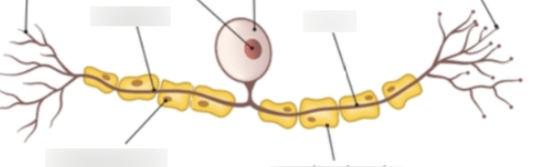

(a) What type of neuron is shown in the diagram?
Chapter 2: Nervous system

(2017:2.31)

[1]

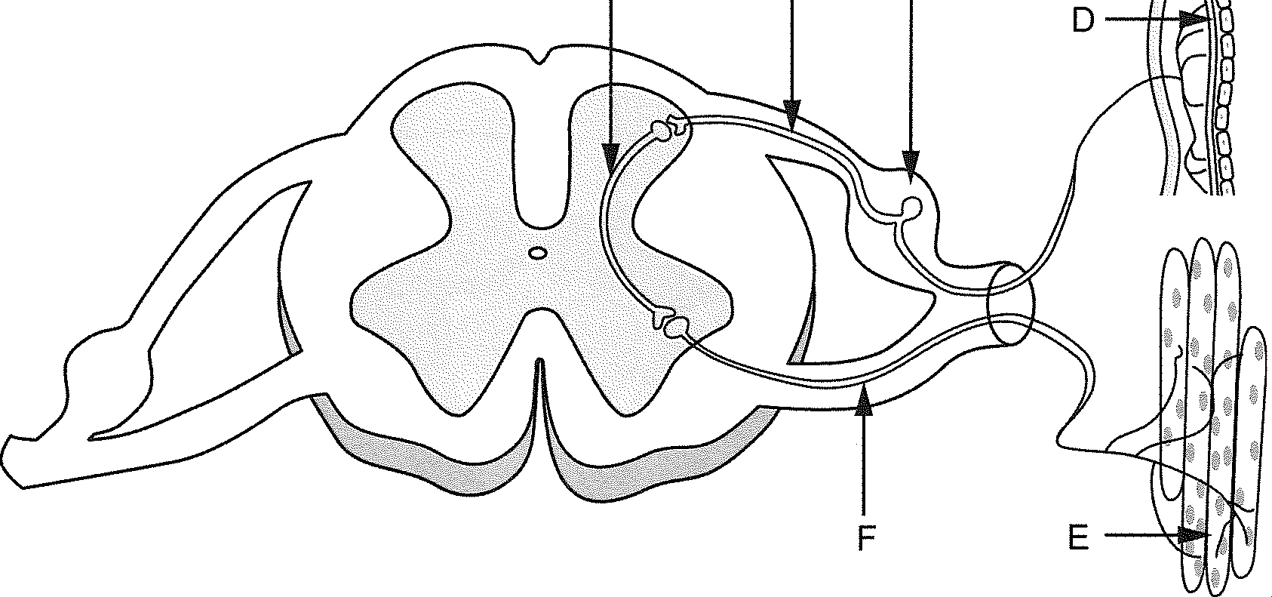
(d) Using the labels in the diagram, identify the following correctly. [2] Sensory neuron: -----------------------------
(b) How does the position of the cell body in other types of neurons differ from the position shown in the diagram? [2]

Interneuron: ------------------------------

- Outline three important functional properties that are associated with all spinal reflexes.
[3]

48

) [12 marks]
The diagram below shows two motor neurons.

Neuron 1 -' Neuron 2

  - Using the information above, complete the following table.
Chapter 2: Nervous system

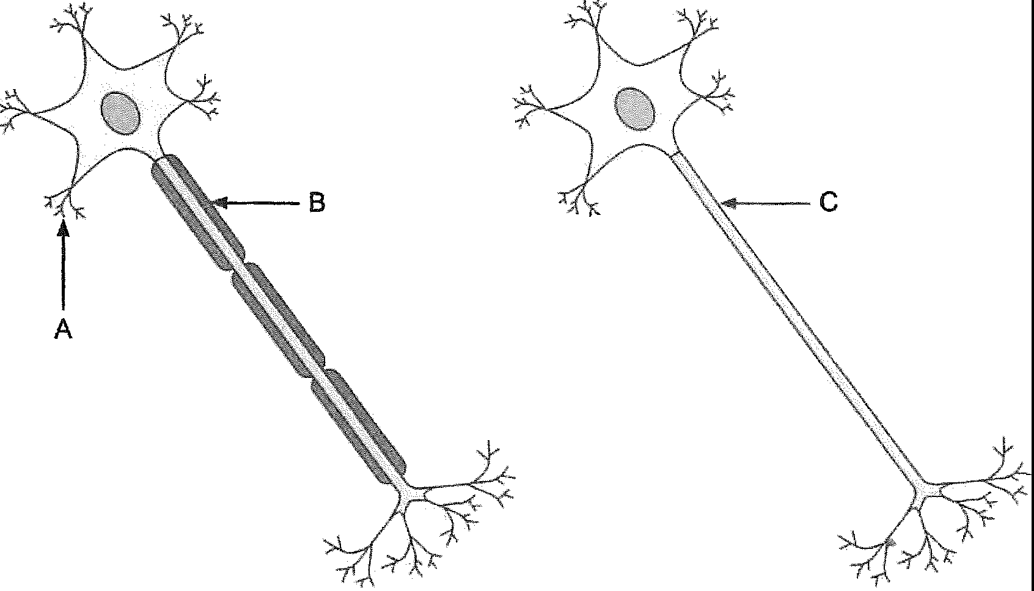
(2018:2.31)

[3]

Label | Structure name
A
B
C

  - Describe why nerve transmission would be much faster in Neuron 1 than in Neuron 2.
[2]

Neuron 1 can be found within the somatic division of the nervous system.

  - (i) To what structures in the body would these neurons take messages? [1]

(ii) How does the pathway of a nerve impulse travelling through the neurons of the somatic division differ to that travelling within the autonomic division? [2]

51

